

**NETWORKING & SYSTEM ADMINISTRATION LAB**

**Experiment No.: 4**

**Aim**

Familiarization of the linux commands.

**Procedure**

1. cat -n

Used to display the content of the file with line numbers.

Syntax :- $ cat -n filename.txt

Output :-

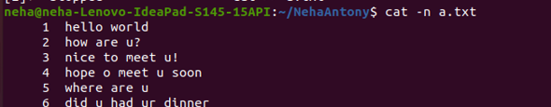

2. cat -b

This command is used to remove empty lines from the file

Syntax :- $ cat -b filename.txt

Output :-



3. touch

The touch command is used to create a file. It can be anything, from an empty txt file to an empty zip file.

Syntax :- $ touch filename.txt

Output :-



4. echo

The "echo" command helps us move some data, usually text into a file. For example, if you want to create a new text file or add to an already made text file, you just need to type in, “echo hello, my name is alok >> new.txt”. You do not need to separate the spaces by using the backward slash here, because we put in two triangular brackets when we finish what we need to write.

Syntax :- $ echo hai dear >> filename.txt

Output :-



5. head

This command is used to display the first N number of lines

Syntax :- $ head filename.txt

Output :-



6. head -4

This command is used to display the first 4 number of lines

Syntax :- $ head -4 filename.txt

Output:-



7. tail

This command is used to display the last N number of lines

Syntax :- $tail filename.txt

Output :-

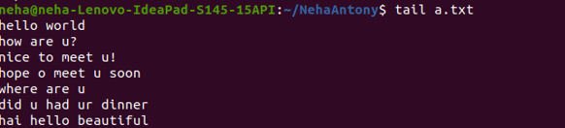

8. cut -d- -f1

**. -f (field):** **-c** option is useful for fixed-length lines. Most unix files doesn’t have fixed-length lines. To extract the useful information you need to cut by fields rather than columns. List of the fields number specified must be separated by comma. *Ranges are not described with -f option*. **cut**uses **tab**as a default field delimiter but can also work with other delimiter by using **-d** option.

Syntax :- $ cut -d- -f1 filename.txt

Output :-



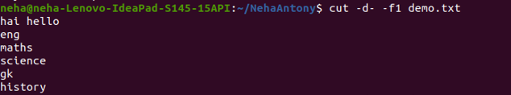

9. cut -d- -f2

This command is used to display files in the last modified order.

Syntax :- $ cut -d- -f2 filename.txt

Output :-

